**Practical No. 8**

1. **Working with Services and Broadcast Recievers in**

**Android**

1. **Services**

**Designing UI**

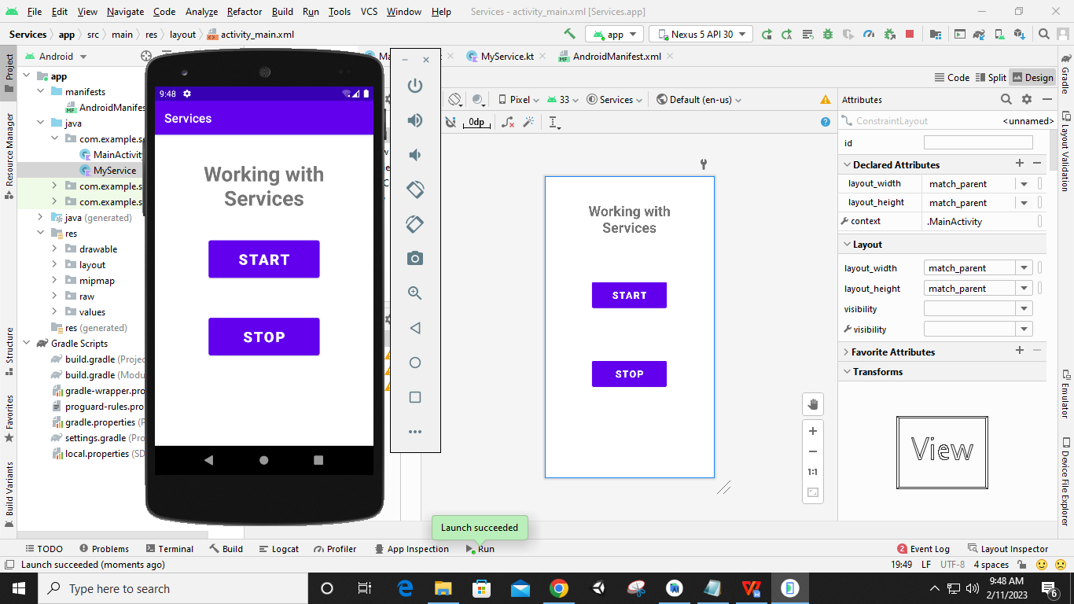

**Code:**

**AndroidManifest.xml**

*<?***xml version="1.0" encoding="utf-8"***?>*<**manifest xmlns:android="http://schemas.android.com/apk/res/android"  
 package="com.example.services"**>  
 <**application  
 android:allowBackup="true"  
 android:icon="@mipmap/ic_launcher"  
 android:label="@string/app_name"  
 android:roundIcon="@mipmap/ic_launcher_round"  
 android:supportsRtl="true"  
 android:theme="@style/Theme.Services"**>  
 <**activity  
 android:name=".MainActivity"  
 android:exported="true"**>  
 <**intent-filter**>  
 <**action android:name="android.intent.action.MAIN"** />  
 <**category android:name="android.intent.category.LAUNCHER"** />  
 </**intent-filter**>  
 </**activity**>  
 <**service  
 android:name=".MyService"  
 android:enabled="true"  
 android:exported="true"**>  
 </**service**>  
 </**application**>  
</**manifest**>

**MainActivity.kt**

**package** com.example.services  
  
**import** android.content.Intent  
**import** androidx.appcompat.app.AppCompatActivity  
**import** android.os.Bundle  
**import** android.widget.Button  
  
**class** MainActivity : AppCompatActivity() {  
 **override fun** onCreate(savedInstanceState: Bundle?) {  
 **super**.onCreate(savedInstanceState)  
 setContentView(R.layout.*activity_main*)  
  
 **var** start:Button=findViewById(R.id.*button1*)  
 **var** stop:Button=findViewById(R.id.*button2*)  
  
 start.setOnClickListener**{  
 var** intent1: Intent =Intent(*applicationContext*,MyService::**class**.*java*)  
 startService(intent1)  
 **}** stop.setOnClickListener**{  
 var** intent1: Intent =Intent(*applicationContext*,MyService::**class**.*java*)  
 stopService(intent1)  
 **}** }  
}

**MyService.kt**

**package** com.example.services  
  
**import** android.app.Service  
**import** android.content.Intent  
**import** android.media.MediaPlayer  
**import** android.os.IBinder  
**import** android.widget.Toast  
  
**class** MyService : Service() {  
 **var mp**:MediaPlayer= MediaPlayer()  
  
 **override fun** onBind(intent: Intent?): IBinder? {  
 **return null**;  
 }  
 **override fun** onStart(intent: Intent,id:Int) {  
 **super**.onStart(intent, id)  
 **mp**=MediaPlayer.create(**this**,R.raw.*kigeki*)  
 **mp**.start()  
 Toast.makeText(*applicationContext*, **"Music Started Playing..."**, Toast.*LENGTH_LONG*).show()  
 }  
 **override fun** onDestroy() {  
 **mp**.stop()  
 Toast.makeText(*applicationContext*, **"Music has Stopped..."**, Toast.*LENGTH_LONG*).show()  
 **super**.onDestroy()  
 }  
}

**Output:**

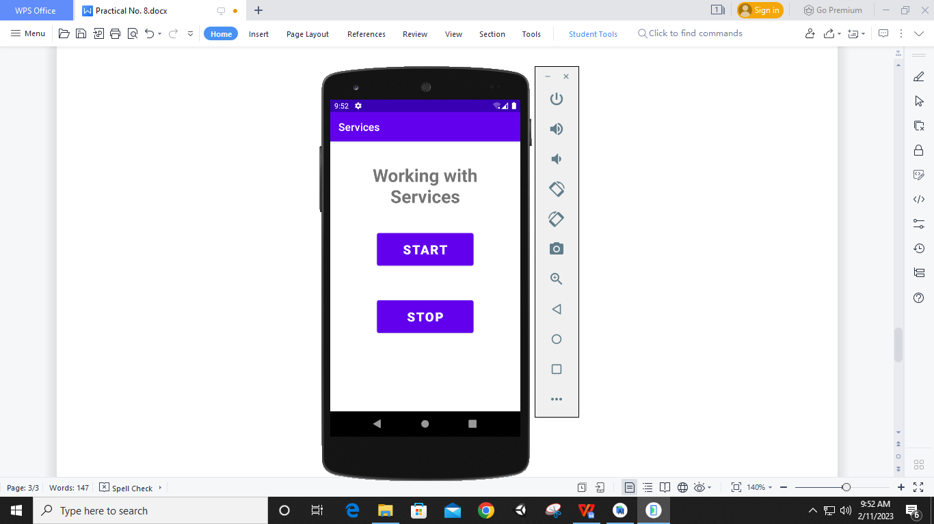

**After Clicking START**

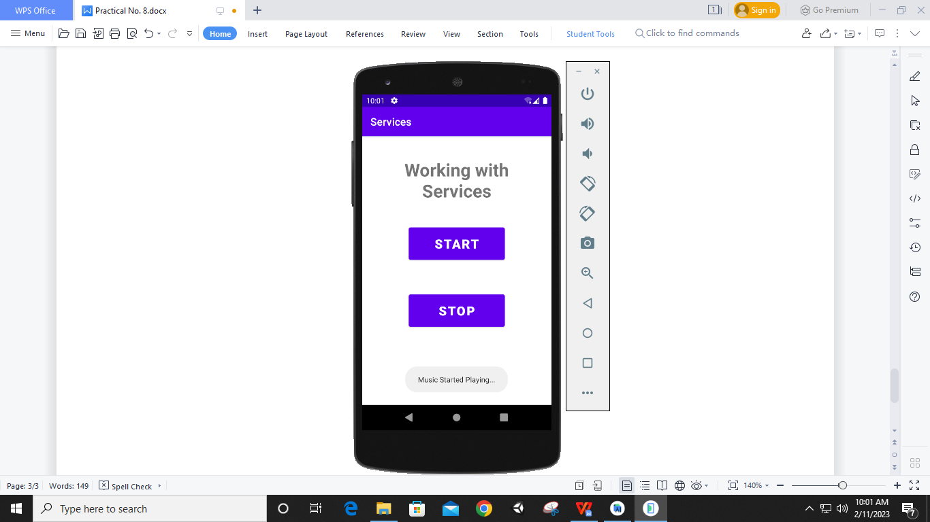

**After Clicking STOP**

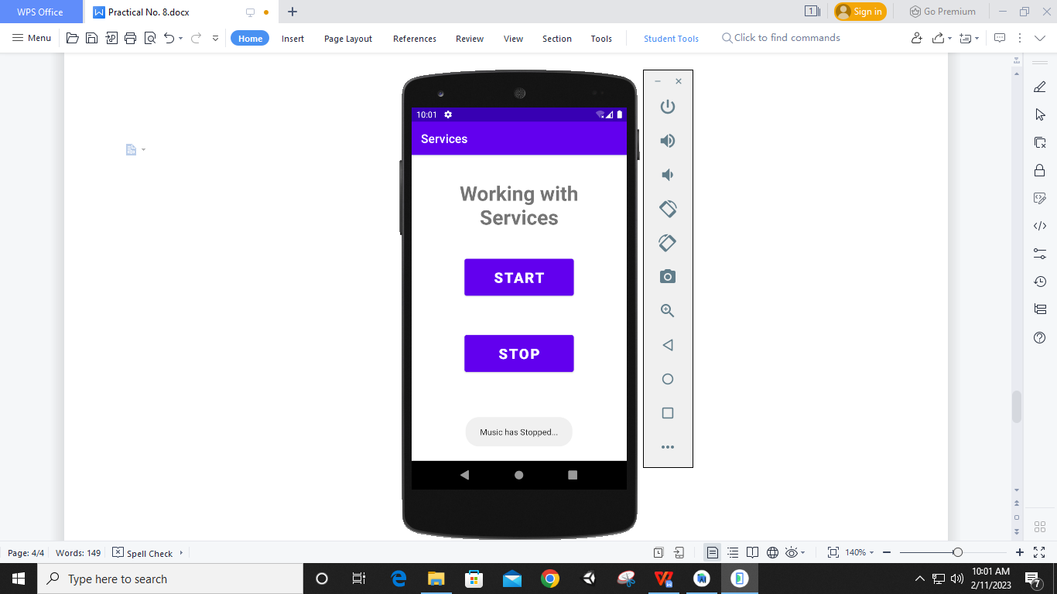

1. **Broadcast Reciever**

**Designing UI**

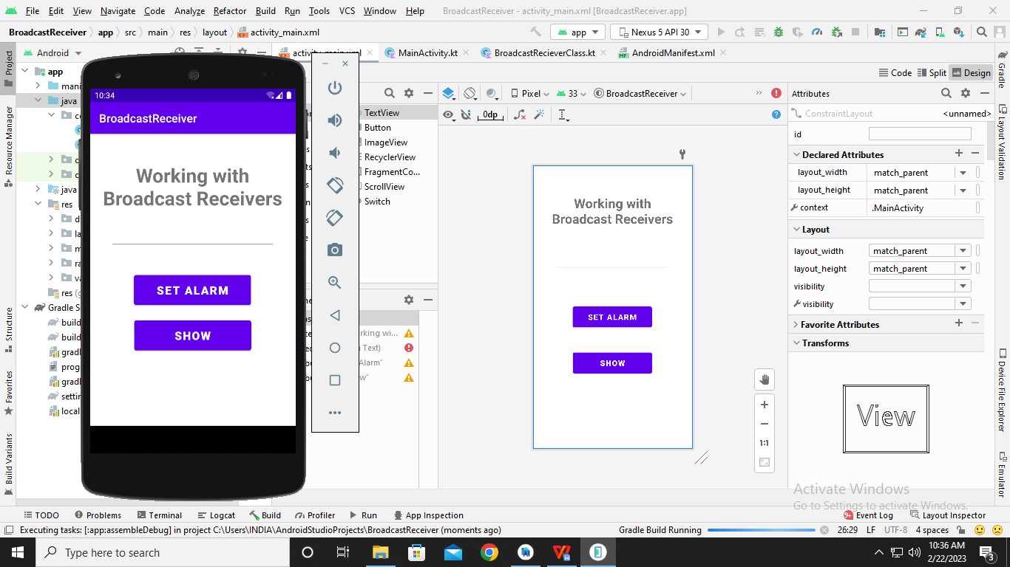

**Code:**

**MainActivity.kt**

**package** com.example.broadcastreceiver  
  
**import** android.app.AlarmManager  
**import** android.app.PendingIntent  
**import** android.content.BroadcastReceiver  
**import** android.content.Intent  
**import** androidx.appcompat.app.AppCompatActivity  
**import** android.os.Bundle  
**import** android.widget.Button  
**import** android.widget.EditText  
  
**class** MainActivity : AppCompatActivity() {  
 **override fun** onCreate(savedInstanceState: Bundle?) {  
 **super**.onCreate(savedInstanceState)  
 setContentView(R.layout.*activity_main*)  
  
 **var** text1:EditText=findViewById(R.id.*edittext*)  
  
 **var** btn1:Button=findViewById(R.id.*button1*)  
 **var** btn2:Button=findViewById(R.id.*button2*)  
  
 btn1.setOnClickListener **{  
 var** time:Int=Integer.parseInt(text1.*text*.toString())  
 **var** intent1:Intent= Intent(*applicationContext*,BroadcastRecieverClass::**class**.*java*)  
 **var** pi:PendingIntent= PendingIntent.getBroadcast(**this**,0,intent1,0)  
 **var** alarm:AlarmManager=getSystemService(*ALARM_SERVICE*) **as** AlarmManager  
 alarm.set(AlarmManager.*RTC_WAKEUP*,System.currentTimeMillis()+(time*1000),pi)  
 **}** btn2.setOnClickListener **{  
 var** intent1:Intent=Intent(*applicationContext*,BroadcastRecieverClass::**class**.*java*);  
 intent1.setAction(**"android.intent.action.ACTION_SHOW_TOAST"**);  
 sendBroadcast(intent1)  
 **}** }  
}

**AndroidManifest.xml**

*<?***xml version="1.0" encoding="utf-8"***?>*<**manifest xmlns:android="http://schemas.android.com/apk/res/android"  
 package="com.example.broadcastreceiver"**>  
  
 <**application  
 android:allowBackup="true"  
 android:icon="@mipmap/ic_launcher"  
 android:label="@string/app_name"  
 android:roundIcon="@mipmap/ic_launcher_round"  
 android:supportsRtl="true"  
 android:theme="@style/Theme.BroadcastReceiver"**>  
 <**activity  
 android:name=".MainActivity"  
 android:exported="true"**>  
 <**intent-filter**>  
 <**action android:name="android.intent.action.ACTION_SHOW_TOAST"**/>  
  
 <**category android:name="android.intent.category.DEFAULT"** />  
 </**intent-filter**>  
 <**intent-filter**>  
 <**action android:name="android.intent.action.MAIN"** />  
  
 <**category android:name="android.intent.category.LAUNCHER"** />  
 </**intent-filter**>  
 </**activity**>  
 <**receiver android:name=".BroadcastRecieverClass"** />  
 </**application**>  
  
</**manifest**>

**BroadcastReceiverClass.kt**

**package** com.example.broadcastreceiver  
  
**import** android.content.BroadcastReceiver  
**import** android.content.Context  
**import** android.content.Intent  
**import** android.media.MediaPlayer  
**import** android.widget.Toast  
  
**class** BroadcastRecieverClass :BroadcastReceiver(){  
 **var mp**:MediaPlayer= MediaPlayer()  
 **override fun** onReceive(context: Context?, intent: Intent?) {  
 **if**(intent != **null**){  
 **if**(intent.*action*.*equals*(**"android.intent.action.ACTION_SHOW_TOAST"**)){  
 Toast.makeText(context,**"Broadcast Received..."**,Toast.*LENGTH_LONG*).show()  
 }  
  
 **else** {  
 **mp** = MediaPlayer.create(context, R.raw.*kigeki*)  
 **mp**.start()  
 Toast.makeText(context, **"Alarm is ringing..."**, Toast.*LENGTH_LONG*).show()  
 }  
 }  
 }  
}

**Output:**

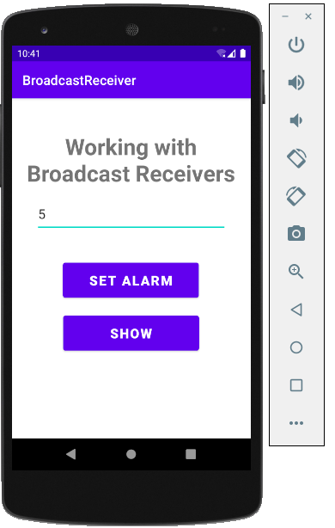

**After Clicking ‘SET ALARM’**

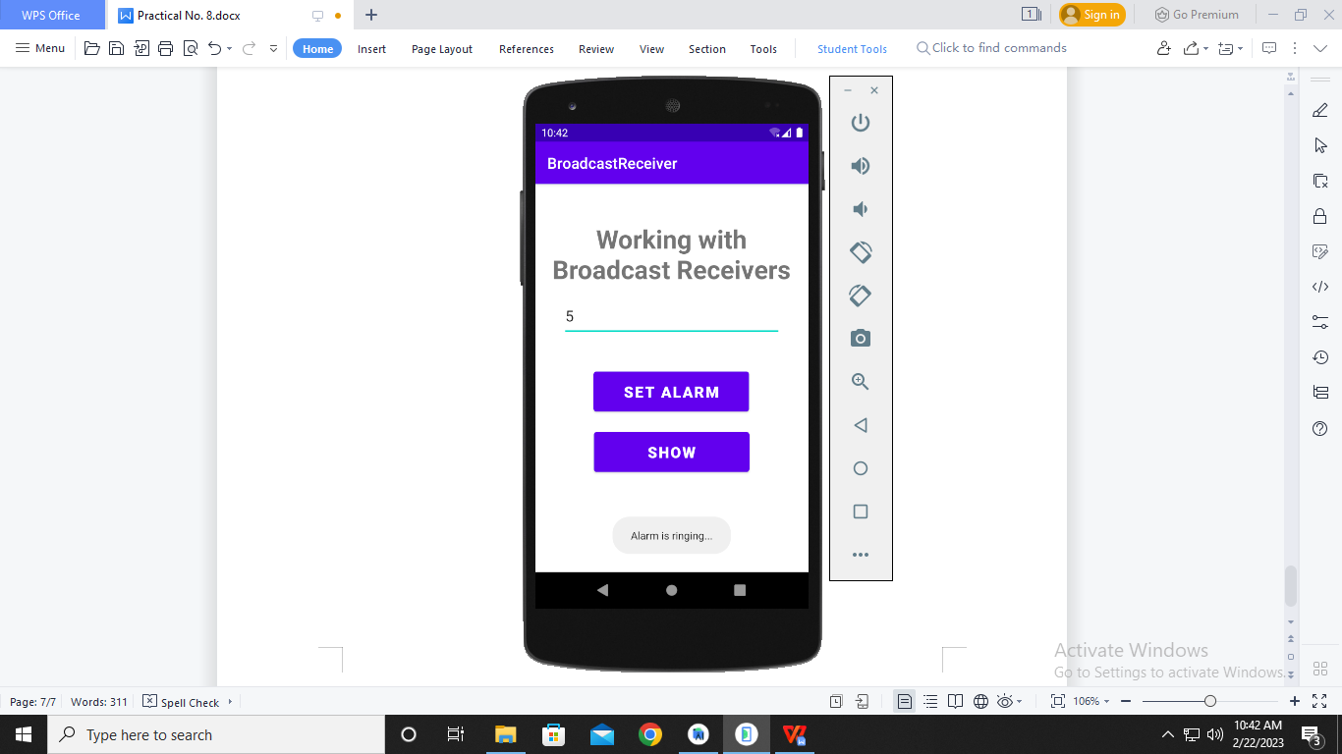

**After Clicking ‘SHOW’**

